WORKSHEET 1 | SPORTS | UNIT 1 – ON THE MOVE
Name:_____________________________________________________ No.:______ Class:_____
Date: ____/____/____ Mark: ________________________ Teacher: _______________________
A. Match these sports verbs with the pictures. One verb is not needed.
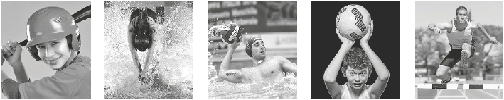
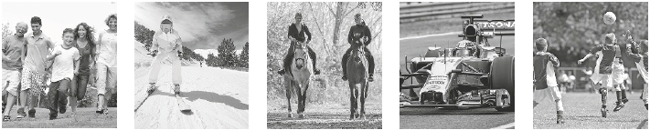
1. __________ 2. __________ 3. __________ 4. __________ 5. __________
• hit • ski • throw • dive • run • ride
• kick • jump • drive • pass • catch
6. __________ 7. __________ 8. __________ 9. __________ 10. __________
B. Choose the correct answer (A, B or C).
1. Football is played on a ___________________.
A field or pitch B court C track
2. The footballer kicked the ball into the ___________________.
A bunker B basket C goal
3. We played tennis in the new ___________________.
A rink B court C course
4. Every morning she swims ten ___________________ of the pool.
A lengths B courses C laps
5. They went to play at the golf __________________.
A court B track C course
6. The Olympics are __________________ every four years.
A held B made C taken
7. She lost the match because a string broke in her _________________.
A club B racket C stick
WORKSHEET 2 | TRAVELLING | UNIT 1 – ON THE MOVE
Name:_____________________________________________________ No.:______ Class:_____
Date: ____/____/____ Mark: ________________________ Teacher: _______________________
Word groups
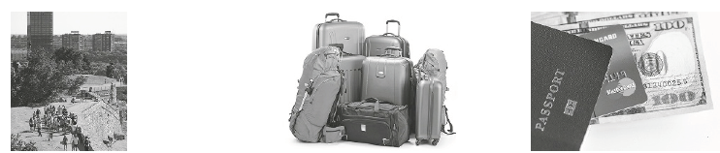
Each group of words belongs to the same lexical field. What is it? The first letters are shown.
1. T ________________ 2. L ________________ 3. D ________________
• destination • holdall • credit card
• guidebook • rucksack • visa
• sightseeing • sleeping bag • passport
• tour guide • suitcase • identity card
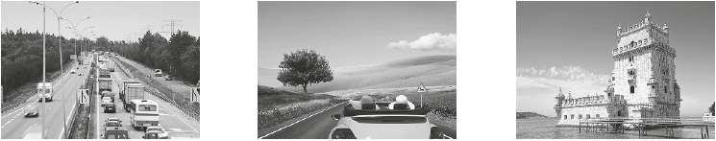
• tour operator • toiletry bag • work permit
4. R _______ T _______ 5. M _________ V ________ 6. M _______________
• convertible • driving licence • Eiffel Tower
• jeep • motorway • Prado Museum
• lorry • number plate • St Paul’s Cathedral
• motorcycle • road signs • Tower Bridge
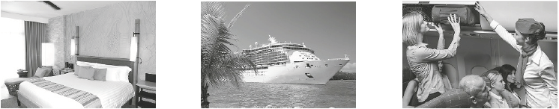
• limo • traffic lights • Tower of Belém
7. A ________________ 8. S_______ T _______ 9. A______ T ________
• bed & breakfast • cruise • landing
• camping site • dock • airfare
• hotel • ferryboat • plane ticket
• motel • harbour • check in
• youth hostel • port • flight
WORKSHEET 3 | TRAVELLING | UNIT 1 – ON THE MOVE
Name:_____________________________________________________ No.:______ Class:_____
Date: ____/____/____ Mark: ________________________ Teacher: _______________________
A. Travel words
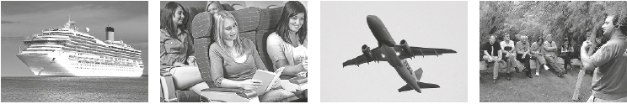
Label the pictures with the words from the box.
• tour guide • backpacker • arrival • cruise
• customs • departure • passenger • flight
1. _______________ 2. _______________ 3. _______________ 4. ______________
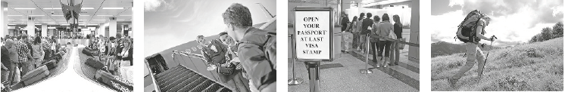
5. _______________ 6. _______________ 7. _______________ 8. ______________
B. Luggage/Baggage
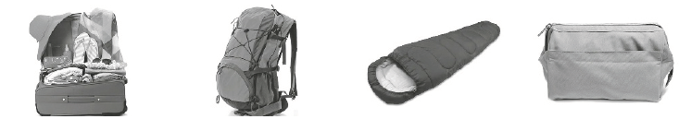
Unscramble the letters to find the words.
1. esactuis 2. Ckurscka 3. lseeginp gab 4. yeiortlt bga
________________ ________________ ________________ _______________
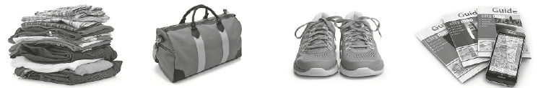
5. lcohtes 6. Adhllol 7. Tairsren 8. geiduboko
________________ ________________ ________________ ________________
WORKSHEET 4 | TRAVELLING | UNIT 1 – ON THE MOVE
Name:_____________________________________________________ No.:______ Class:_____
Date: ____/____/____ Mark: ________________________ Teacher: _______________________
On the road
Choose the correct answer in each case.
1. If the police stop a driver, he/she will probably have to show them his/her _________________.
a) photo
b) driving licence
c) permission
d) patent
2. As that driver was going over the ___________________, she was fined for speeding.
a) speed rule
b) speed maximum
c) speed barrier
d) speed limit
3. It is the driver’s responsibility to ensure all passengers in the car are wearing their __________.
a) belts
b) harnesses
c) seat belts
d) safety harnesses
4. After you leave the city, there’s a large ___________ and you’ll be able to get where you want really quickly.
a) highway
b) street
c) lane
d) path
5. When it is very dark, you turn the ___________ on so you can see the road.
a) headphones
b) headlights
c) taillights
d) panel lights
6. Whenever you want to shift up or down, you press the ___________ down.
a) gas
b) accelerator
c) clutch pedal
d) brake pedal

WORKSHEET 5 | TRAVELLING | UNIT 1 – ON THE MOVE
Name:_____________________________________________________ No.:______ Class:_____
Date: ____/____/____ Mark: ________________________ Teacher: _______________________
A. Transport verbs
Read the clues and find the ten missing transport verbs in the grid. They may go horizontally, vertically or diagonally.
1. To go by operating a car is to d ____________.
2. To leave or set off is to d ____________.
3. To get to where you are going is to a ____________.
4. To go by bus, train, bike or horse is to r ____________.
5. To go by plane or helicopter is to f ____________.
6. To go somewhere by boat is to s ____________.
7. To pull another boat or car behind yours is to t ____________.
8. To come back to the ground in an airplane is to l ____________.
9. To leave the ground in an airplane is to t ____________ ____________.
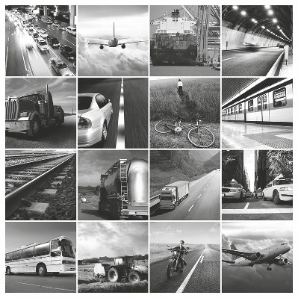
10. To get off a boat or an airplane is to d ____________.
S | A | D | E | R | T | I | S | P | L | R | S | N
D | R | I | V | E | N | H | A | Q | S | I | T | Y
E | X | E | R | U | I | N | J | C | O | D | B | E
P | Q | E | R | I | H | N | L | E | R | E | G | I
A | R | R | I | V | E | B | E | R | U | Y | O | T
R | S | A | I | L | R | T | E | R | U | Y | O | A
T | O | W | V | D | I | S | E | M | B | A | R | K
W | A | E | R | T | E | N | H | J | O | I | P | E
D | F | B | G | T | I | O | L | K | N | H | F | O
S | E | L | A | N | D | B | R | T | I | O | T | F
E | R | T | Y | M | H | J | I | O | R | T | V | F
D | E | R | T | Y | U | F | S | A | I | L | Y | B
B. Travel words
Match the words on the left with their definitions on the right.
1. timetable a) journey made by air
2. cruise b) a long journey by sea
3. trip c) a journey by sea, visiting different places, especially as a holiday
4. excursion d) act of arriving
5. tour guide e) a short organised visit to a particular place
6. voyage f) a journey to and from a particular place (informal)
7. flight g) it says when trains/planes depart and arrive
8. arrival h) person who shows tourists interesting sights on a journey
9. platform i) money charged for a journey by bus, taxi, ship, etc.
10. fare j) place where you stand when you are waiting for a train
WORKSHEET 6 | ENTERTAINMENT | UNIT 2 – A QUESTION OF ART
Name:_____________________________________________________ No.:______ Class:_____
Date: ____/____/____ Mark: ________________________ Teacher: _______________________
The three words in each group below start with the same two letters. Write them in the grid. Look at the pictures for help.
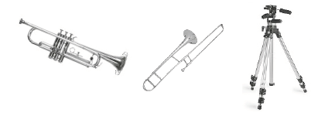
A
1 |  |  | U | M | P | E | T
2 |  |  | O | M | B | O | N | E
3 |  |  | I | P | O | D
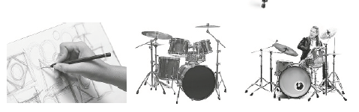
B
1 |  |  | A | W | I | N | G
2 |  |  | U | M
3 |  |  | U | M | M | E | R
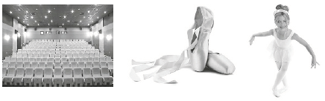
C
1 |  |  | L | C | O | N | Y
2 |  |  | L | L | E | T
3 |  |  | L | L | E | R | I | N | A
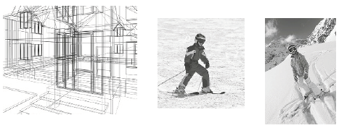
D
1 |  |  | E | T | C | H
2 |  |  | I | E | R
3 |  |  | I | I | N | G
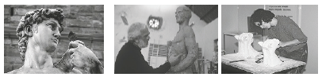
E
1 |  |  | U | L | P | T | U | R | E
2 |  |  | U | L | P | T | O | R
3 |  |  | U | L | P | T | R | E | S | S
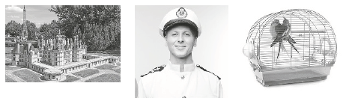
F
1 |  |  | S | T | L | E
2 |  |  | P | T | A | I | N
3 |  |  | G | E

WORKSHEET 7 | CINEMA | UNIT 2 – A QUESTION OF ART
Name:_____________________________________________________ No.:______ Class:_____
Date: ____/____/____ Mark: ________________________ Teacher: _______________________
At the cinema

A. Read the clues to solve the crossword. What is the name of the film that appears in the grey column?
 |  |  |  |  | 1 | U |  |  |  | R
 |  |  |  |  |  | 2 | C |  |  |  |  | A
 |  |  |  |  |  | 3 | T |  |  |  |  | T
 |  |  |  |  | 4 | S |  |  |  |  | N
5 | B |  |  |  |  |  |  |  |  |  |  | S
 |  |  |  |  |  |  | 6 | P |  |  | T
 |  |  |  |  |  | 7 | P |  |  |  |  |  |  |  | R
 |  |  | 8 | A |  |  |  |  |  |  |  | N
 |  | 9 | C |  |  |  |  | Y
1. An _______________ is a person who shows you to your seat and makes sure everybody is quiet during the film.
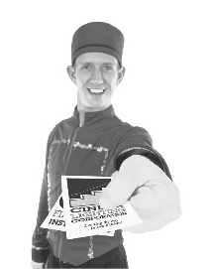
2. The film is filmed with a _______________.
3. To see a film, usually, you have to buy a _______________.
4. The film is projected onto a large _______________.
5. Films with big budgets that sell a lot of tickets are called _______________.
6. What happens in a film is called the _______________.
7. The film is projected using a film _______________.
8. An _______________ film has cartoon characters.
9. A film that makes you laugh is a _______________.
B. Jobs in the film industry
Match the jobs on the left with their definitions on the right.
1. The make-up artist ___ a) makes or supplies theatrical or fancy costumes.
2. The costumier ___ b) operates a film or television camera.
3. The stuntman ___ c) applies cosmetics to a person, such as to a model or actor.
4. The director ___ d) creates and designs sets for plays, films or television productions.
5. The camera operator ___ e) performs dangerous acts in place of an actor.
6. The set designer ___ f) is responsible for the artistic and technical aspects of making a film.
WORKSHEET 8 | TECHNOLOGY | UNIT 3 – TECHNOLOGY IS GREAT!
Name:_____________________________________________________ No.:______ Class:_____
Date: ____/____/____ Mark: ________________________ Teacher: _______________________
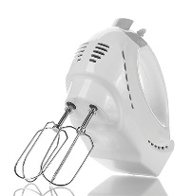
Home appliances
Circle the appliance that best fits each definition.
1. A kitchen utensil for beating eggs, etc. very fast.
a) electric whisk
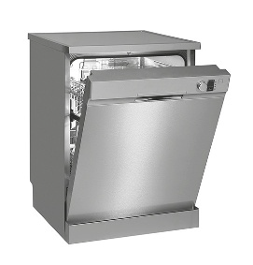
b) blender
c) food processor
2. A large piece of equipment for cooking food.
a) cook
b) cooker
c) cookie
3. A machine for washing plates, cups, etc.
a) dishwater
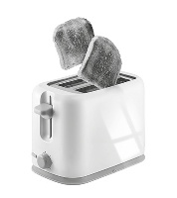
b) dishcloth
c) dishwasher
4. An electrical machine that you put slices of bread in to make toast.
a) toaster
b) toastie
c) toasty
5. An electrical machine that cleans floors, carpets, etc. by sucking up dirt and dust.
a) vacuum
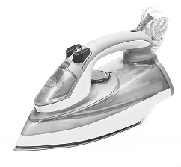
b) vacuum flask
c) vacuum cleaner
6. You use it to press your clothes.
a) kettle
b) iron
c) freezer
7. A type of oven that cooks or heats food very quickly using electromagnetic waves rather than heat.
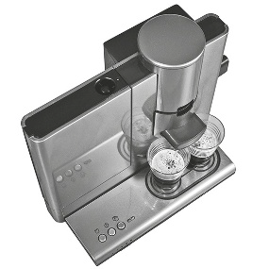
a) microlight
b) microwave
c) microprocessor
8. A small machine for making cups of coffee.
a) cafeteria
b) coffee bar
c) coffee machine

WORKSHEET 9 | TECHNOLOGY | UNIT 3 – TECHNOLOGY IS GREAT!
Name:_____________________________________________________ No.:______ Class:_____
Date: ____/____/____ Mark: ________________________ Teacher: _______________________
Computer-related vocabulary
A. Find these computer terms in the puzzle. They go across and down.
S | O | U | I | P | J | S | F | G | E | Q | V | B | I | O
D | M | U | I | O | P | C | N | M | E | V | I | R | U | S
T | O | O | L | B | A | R | G | U | I | N | G | S | E | P  • monitor • keyboard  • screen • delete  • menu • mouse  • file • speaker  • cursor • cable  • window • disk  • trash • virus  • toolbar • spellchecker
S | N | A | Q | W | R | E | T | C | A | B | L | E | N | E
R | I | V | F | O | M | E | N | U | D | E | R | O | P | L
X | T | S | A | F | R | N | E | R | G | Y | S | I | O | L
H | O | N | J | K | O | P | L | S | F | R | P | D | E | C
T | R | A | S | H | D | E | M | O | U | S | E | S | U | H
A | S | D | F | G | H | U | I | R | O | P | A | L | W | E
K | E | Y | B | O | A | R | D | S | D | F | K | Y | I | C
S | D | F | E | T | Y | I | O | P | M | H | E | J | N | K
D | E | L | E | T | E | S | A | D | B | R | R | Q | D | E
S | A | D | F | G | H | H | J | I | E | R | F | S | O | R
S | A | R | T | I | O | P | L | S | S | E | R | V | W | O
C | A | P | F | I | L | E | C | K | S | A | R | T | Y | N

B. Match the words with their translation.
1. monitor a) cabo
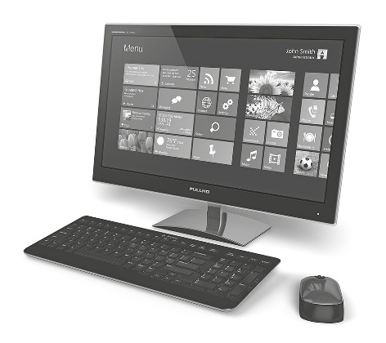
2. screen b) rato
3. menu c) teclado
4. file d) monitor
5. cursor e) menu
6. window f) apagar
7. trash g) coluna
8. toolbar h) vírus
9. keyboard i) cursor
10. delete j) janela
11. mouse k) lixo
12. speaker l) barra de ferramentas
13. cable m) disco
14. disk n) ficheiro
15. virus o) corretor ortográfico
16. spellchecker p) ecrã

WORKSHEET 10 | KEEPING FIT AND HEALTHY | UNIT 4 – HEALTH AND FITNESS
Name:_____________________________________________________ No.:______ Class:_____
Date: ____/____/____ Mark: ________________________ Teacher: _______________________
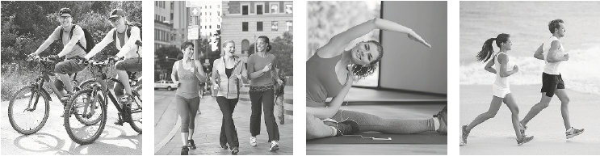
A. These are some of the activities you can do to keep fit. What do you call them?
1. _______________ 2. _______________ 3. _______________ 4. ______________
B. Read the following tips for keeping fit and healthy. Cross out (X) the word in each pair that doesn’t fit the context.
Get enough sleep
Getting enough sleep is necessary to stay fit and unhealthy/healthy. Lack of sleep affects our physical and mental health a lot/a little. It also affects our mood, concentration, memory, motor skills and even the immune system and cardiovascular health. Sleep allows/avoids the body to heal, repair and rejuvenate.
Exercise
Exercise is important for being fit/fat and healthy. We should walk briskly for at least a few minutes every day to stay fit. It also improves circulation and can help increase/fight depression.
Eat healthy food
Eat lots/few of fresh fruits, vegetables and whole grains to stay healthy and fit. Also include lean sources of protein such as poultry, fish, tofu and beans into your diet. One would/should eat a balanced meal and not overeat.
Do not skip breakfast
You should have a healthy breakfast as it keeps you energetic/sleepy. Eating breakfast helps to maintain stable blood sugar levels and a healthy weight because you are more/less likely to overindulge later in the day.
Drink plenty of water
Drink plenty of water as it makes/helps to keep our bodies hydrated and thus healthy. It is the natural cleanser for our organs and digestive system.

WORKSHEET 11 | HEALTH PROBLEMS | UNIT 4 – HEALTH AND FITNESS
Name:_____________________________________________________ No.:______ Class:_____
Date: ____/____/____ Mark: ________________________ Teacher: _______________________
A. Compound words
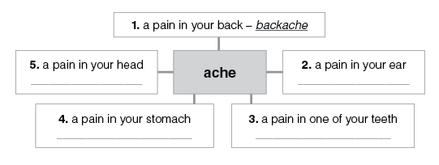
Read the definitions and form compound words which include ache, as in the example (1).

B. What’s the matter?
Choose the correct word to complete each numbered sentence below. Then, match the symptoms (1 – 8) with the pieces of advice (a – h).
• headache • fever • pain
• nose • toothache • cough
• sore • earache
1. I feel awful. I’ve got a bad cold and a ___ a) You should go to the dentist
___________.
2. I’ve got a runny ___________ and no ___ b) You should see the doctor.
handkerchief!
3. I think I’ve got a ___________. I’m hotter ___ c) Why don’t you take some cough syrup than usual. and go to bed?
4. My ear hurts. I’ve got an ____________. ___ d) Try honey mixed in tea.
5. I’ve got a ___________ in my chest. ___ e) Here’s a pack of tissues. Blow your nose!
6. My throat hurts. I’ve got a ___________ ___ f) Take an aspirin.
throat.
7. My tooth hurts. I’ve got a ___________. ___ g) Go to a chemist’s shop and ask for drops.
8. Today I feel bad. I’ve got a terrible ___ h) You should use a thermometer to see ___________. your temperature and take paracetamol to reduce the fever.

WORKSHEET 12 | JOBS | UNIT 5 – @ WORK
Name:_____________________________________________________ No.:______ Class:_____
Date: ____/____/____ Mark: ________________________ Teacher: _______________________

A. What do these people do in their jobs? Choose the right job for each of the sentences below.
1. ___________________ tell visitors about places.
a) Cooks
b) Farmers
c) Firefighters
d) Fishermen
e) Lawyers
f) Lorry drivers
g) Motor mechanics
h) Nannies
i) Radiographers
j) Receptionists
k) Secretaries
l) Shoemakers
m) Shop assistants
n) Stevedores and dockers
o) Tour guides
2. _________________ assist administration in offices.
3. _________________ help customers in shops.
4. ___________________ repair cars and motorbikes.
5. _________________ care for little children.
6. ___________________ give legal advice.
7. _________________ make X-ray images.
8. ___________________ catch sardine, cod and other fish.
9. __________________ receive people when they arrive.
10. ________________drive large goods vehicles.
11. _________________ make and mend footwear.
12. ________________load and unload ships.
13. _________________ plant and harvest crops.
14. ________________put out fires and rescue people.
15. ________________prepare meals in kitchens.
B. Noun formation
Who does these things? Follow the example.

1. report – reporter 8. design – __________________
2. edit – ____________________ 9. build – _____________________
3. history – __________________ 10. employ – __________________
4. paint – _________________ 11. interpret – ________________
5. law – ____________________ 12. sail – ______________________
6. biology – _________________ 13. garden – ___________________
7. physics – _________________ 14. weld (metal) – _______________

WORKSHEET 13 | JOBS AND WORKPLACES | UNIT 5 – @ WORK
Name:_____________________________________________________ No.:______ Class:_____
Date: ____/____/____ Mark: ________________________ Teacher: _______________________
A. Match the job with the place of work.

1. musician a) restaurant
2. salesperson b) street
3. waiter c) bank, supermarket
4. steward d) concert hall
5. cashier e) surgery
6. miner f) shop
7. porter g) university
8. dustman h) plane
9. judge i) studio
10. stockbroker j) mine
11. photographer k) office
12. chancellor l) doorway of a hotel, college, etc.
13. typist m) stock exchange
14. dentist n) court
B. Where do they work? Complete the sentences. Follow the example.
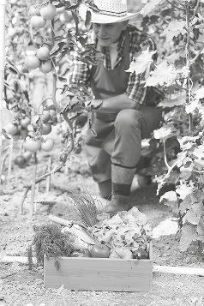
1. A farmer _____________________________________________.
2. A nurse works in __________________________________.
3. A shop assistant ______________________________________.
4. A bank clerk _________________________________________.
5. A teacher ____________________________________________.
6. An architect __________________________________________.
7. A hairdresser _________________________________________.
8. A scientist _______________________________________.
9. A factory worker ______________________________________.
10. A headmaster/mistress _______________________________.
C. Complete these definitions. Follow the example.
1. An accountant is a person whose job is to keep and examine the money accounts of businesses or people.
2. An archaeologist _______________________________________________________________________________.
3. A bricklayer
______________________________________________________________________________.
4. A veterinarian _______________________________________________________________________________.
5. A construction worker _______________________________________________________________________________.
6. A dietician
_______________________________________________________________________________.
7. An optician
_______________________________________________________________________________.
WORKSHEET 14 | FRIENDS | UNIT 6 – CARING ABOUT THE OTHERS
Name:_____________________________________________________ No.:______ Class:_____
Date: ____/____/____ Mark: ________________________ Teacher: _______________________
Read this description attentively.

My best friend
My favourite friend is Sofia, who is also my best friend. I like her very much because she’s a very sensible and loyal person. She is fifteen. She is elegant and tall. She has long, curly, dark brown hair. She wears contact lenses, earrings, necklaces and always wears trousers. She has a long face and when she smiles she has dimples.
She has a strong personality. She is hard-working, generous, reliable and quite ambitious. Sometimes, she gets really insecure because she doesn’t trust herself. Despite being a little conceited, she is a very sensitive person. She cares about poverty and green issues very much. To fight pollution and to promote Earth’s health, she is a member of a green club (an environmentalist association).
When she goes to the cinema and to the theatre, she enjoys herself very much. She is always telling jokes and makes me laugh. She gets really excited when she plays tennis because she loves that sport even more than she likes bowling.
I think I have mentioned her most important qualities and the reasons why I like her.
A. Complete the table with information from the description.
Physical characteristics | Psychological traits | Distinguishing features
B. Describe a person you know well and like. Write 60-70 words.
______________________________________________________________________________
_______________________________________________________________________________
_______________________________________________________________________________
________________________________________________________________________________
________________________________________________________________________________

ANSWERS KEY VOCABULARY
WORKSHEET 1
A. 1. run; 2. ski; 3. ride; 4. drive; 5. kick; 6. hit; 7. dive; 8. pass; 9. throw; 10. jump
B. 1. A; 2. C; 3. B; 4. A; 5. C; 6. A; 7. B
WORKSHEET 2
1. Tourism
2. Luggage (baggage, AmE)
3. Documents
4. Road traffic
5. Motor vehicles
6. Monuments
7. Accommodation
8. Sea travel
9. Air travel
WORKSHEET 3
A. B.
1. cruise 1. suitcase
2. passenger 2. rucksack
3. flight 3. sleeping bag
4. tour guide 4. toiletry bag
5. arrival 5. clothes
6. departure 6. holdall
7. customs 7. trainers
8. backpacker 8. guidebook
WORKSHEET 4
1. b; 2. d; 3. c; 4. a; 5. b; 6. c
WORKSHEET 5
A.
1. drive
2. depart
3. arrive
4. ride
5. fly
6. sail
7. tow
8. land
9. take off
10. disembark
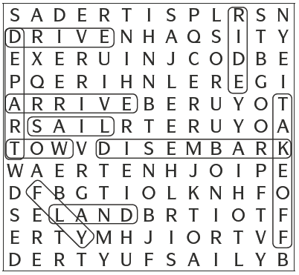

B.
1. g; 2. c; 3. f; 4. e; 5. h; 6. b; 7. a; 8. d; 9. j; 10. i
WORKSHEET 6
A | 1 | T | R | U | M | P | E | T
A | 2 | T | R | O | M | B | O | N | E
A | 3 | T | R | I | P | O | D

B | 1 | D | R | A | W | I | N | G
B | 2 | D | R | U | M
B | 3 | D | R | U | M | M | E | R

C | 1 | B | A | L | C | O | N | Y
C | 2 | B | A | L | L | E | T
C | 3 | B | A | L | L | E | R | I | N | A

D | 1 | S | K | E | T | C | H
D | 2 | S | K | I | E | R
D | 3 | S | K | I | I | N | G

E | 1 | S | C | U | L | P | T | U | R | E
E | 2 | S | C | U | L | P | T | O | R
E | 3 | S | C | U | L | P | T | R | E | S | S

F | 1 | C | A | S | T | L | E
F | 2 | C | A | P | T | A | I | N
F | 3 | C | A | G | E

WORKSHEET 7
A.
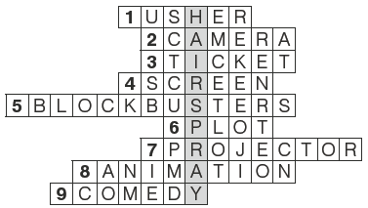

Film: Hairspray
B.
1. c); 2. a); 3. e); 4. f;) 5. b); 6. d)
WORKSHEET 8
1. a); 2. b); 3. c); 4. a); 5. c); 6. b); 7. b); 8. c)

WORKSHEET 9
A.
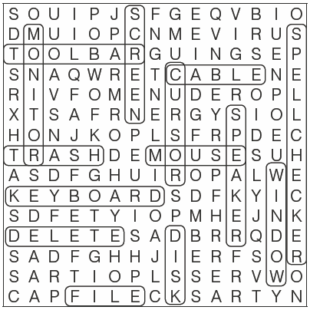
B.
1. d; 2. p; 3. e; 4. n; 5. i; 6. j; 7. k; 8. l; 9. c; 10. f; 11. b; 12. g; 13. a; 14. m; 15. h; 16. o
WORKSHEET 10
A.
1. Cycling
2. Walking
3. Doing gymnastics
4. Jogging/Running
B.
Right words
healthy; a lot; allows; fit; fight; lots; should; energetic; less; helps
WORKSHEET 11
A.
2. earache
3. toothache
4. stomach ache
5. headache
B.
1. c) cough
2. e) nose
3. h) fever
4. g) earache
5. b) pain
6. d) sore
7. a) toothache
8. f) headache
WORKSHEET 12
A.
1. o); 2. k); 3. m); 4. g); 5. h); 6. e); 7. i); 8. d); 9. j); 10. f; 11. l); 12. n); 13. b); 14. c); 15. a)
B.
2. editor
3. historian
4. painter
5. lawyer
6. biologist
7. physicist
8. designer
9. builder
10. employer
11. interpreter
12. sailor
13. gardener
14. welder

WORKSHEET 13
A.
1. d); 2. f); 3. a); 4. h); 5. c); 6. j); 7. l); 8. b); 9. n);
10. m); 11. i); 12. g); 13. k); 14. e)
B.
2. A nurse works in a hospital.
3. A shop assistant works in a shop.
4. A bank clerk works in a bank.
5. A teacher works in a school.
6. An architect works in an office/at a building site.
7. A hairdresser works in a saloon.
8. A scientist works in a lab/laboratory.
9. A factory worker works in a factory.
10. A headmaster mistress works in a school.
C.
2. An archaeologist is a person whose job is to examine ancient sites and objects to learn about the past.
3. A bricklayer or mason (AmE) is a craftsman who lays bricks to construct brickwork.
4. A veterinarian is a person whose job is to treat animals.
5. A construction worker is someone whose job is to work on a construction site where structures such as bridges or houses are being built.
6. A dietician is an expert on diet and nutrition whose job is to advise people on what to eat.
7. An optician is a person whose job is to examine people’s eyes and to recommend and sell glasses.
WORKSHEET 14
A.
Physical characteristics: elegant and tall; long, curly, dark brown hair; a long face; dimples
Psychological traits: sensible and loyal; strong personality; hard-working; generous; reliable; quite ambitious; insecure; a little conceited but sensitive; funny
Distinguishing features: wears contact lenses, earrings, necklaces; always wears trousers
B.
Personal answer.

